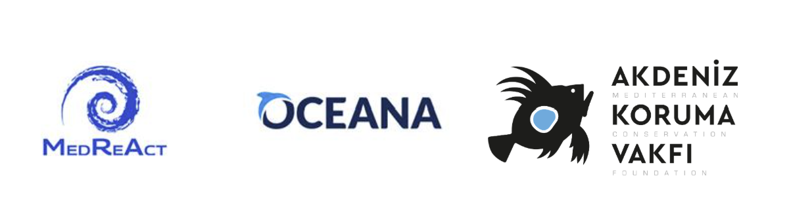
MEDIA RELEASE
Mediterranean deep-sea: Italy and Spain block Türkiye’s proposal to extend ban on bottom trawling, putting fragile deep-water ecosystems at risk
Rome, 30/10/2026 - Led by Italy and Spain, the European Union (EU) has dealt a shameful blow to deep-sea protection by blocking a decision to extend the deep-sea bottom trawling ban in the Mediterranean and Black Sea from 1,000 to 800 metres depth, missing a historic opportunity to strengthen protection of the Mediterranean deep sea. The proposal was put forward by the Republic of Türkiye at the General Fisheries Commission for the Mediterranean’s (GFCM) annual meeting (Rome, 26-30 October 2026), and backed by Egypt, Lebanon, Montenegro and Morocco.
The European Commission initiated the GFCM discussions on the measure in 2023, and publicly supported the extension at the AgriFish Council in June 2026. Yet, Italy and Spain refused to even consider a two years phase-in of the ban proposed by Türkiye, without providing any reasonable justification.
In view of Italy and Spain’s determination to sink the proposal, Türkiye announced that it will retable it next year, at the GFCM annual session in Ankara. NGOs attending this year’s meeting as observers witnessed for the first time the massive presence of industry representatives on the part of the Italian delegation.
The setback leaves vulnerable deep-sea habitats exposed to fishing impacts, despite their importance for marine biodiversity, climate resilience, and the recovery of overexploited high-value stocks such as red shrimp. With the Mediterranean warming more rapidly than other oceans and facing more intense marine heatwaves, the measure’s rejection is particularly difficult to justify given the negligible socio-economic impact of such a ban, identified by GFCM pilot studies across the region, on the fishing sector.
Zafer Kızılkaya, President of Mediterranean Conservation Foundation (Akdeniz Koruma Vakfı), said: "Türkiye has shown that a Mediterranean country can lead on deep-sea protection, and it was backed by countries on both shores of the basin. It is deeply disappointing that Italy and Spain chose to block a measure with negligible costs for the fishing sector and lasting benefits for biodiversity and fish stocks. We will keep working with our partners so that the ban is extended in Ankara next year."
Domitilla Senni, MedReAct Director, said: “We urge Mediterranean countries and the EU to maintain momentum and extend the deep-sea trawling ban in 2027 at the latest, and we congratulate the leadership by Türkiye and countries that already introduced national bans on bottom trawling below 800 metres, including Egypt, Montenegro and France”.
Vera Coelho, Executive Director and Vice President at Oceana in Europe, said: “This failure to act is a disgrace, as Italy and Spain are able to hold hostage the entire Mediterranean region for the sake of a few industrial deep-sea trawlers, when it is proven that the economic impacts are minimal. As the region is suffering from intense heatwaves, precaution should prevail to protect the important role of deep-sea ecosystems as climate refugia. This outcome also raises concerns about the EU’s stated leadership and ability to deliver ocean conservation in practice.”
ENDS
CONTACTS:
Luisa Colasimone, MedReAct Senior Communications Advisor; lglcolasimone@gmail.com; + 32 479 100 067
Emily Fairless, Oceana Senior Communications Officer;efairless@oceana.org; +32 478 038 490

